Cloud guard with custom policy for monitoring logs and resource data:
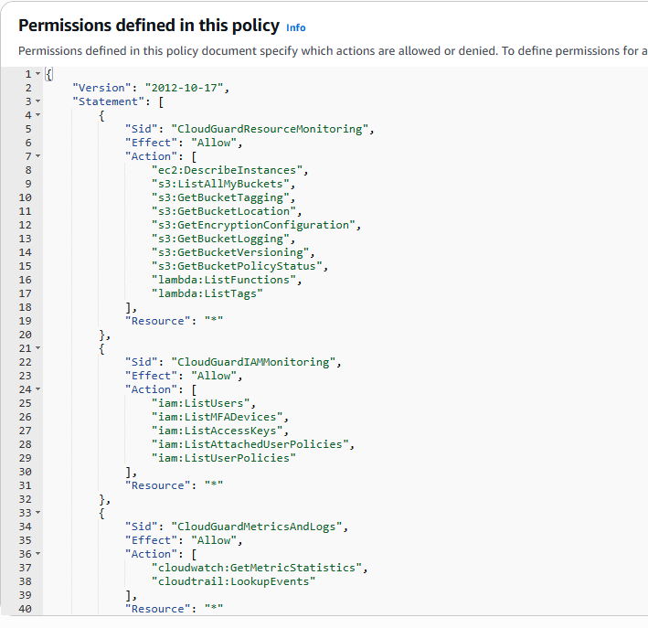
Different user for testing purpose:
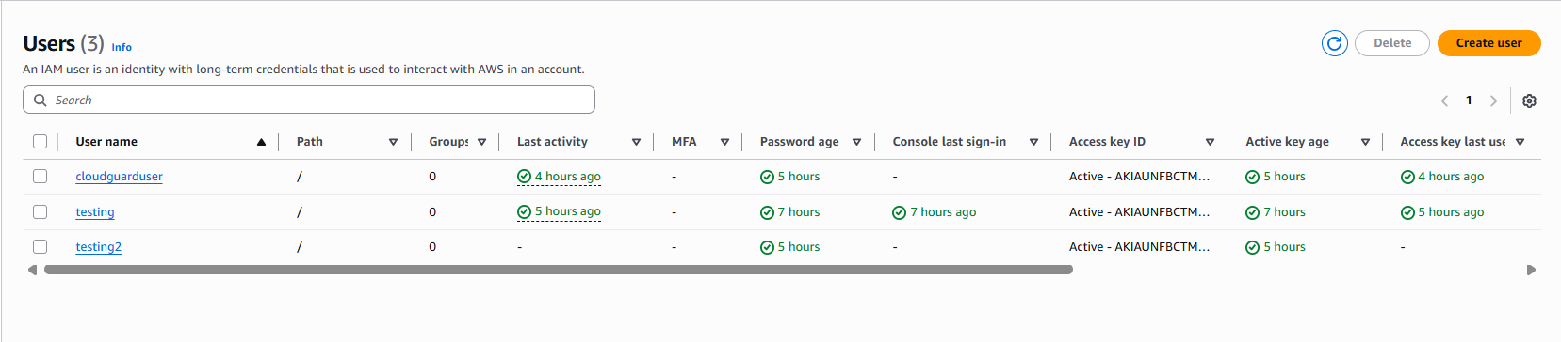

Custom policy for other users so that they can use any service:
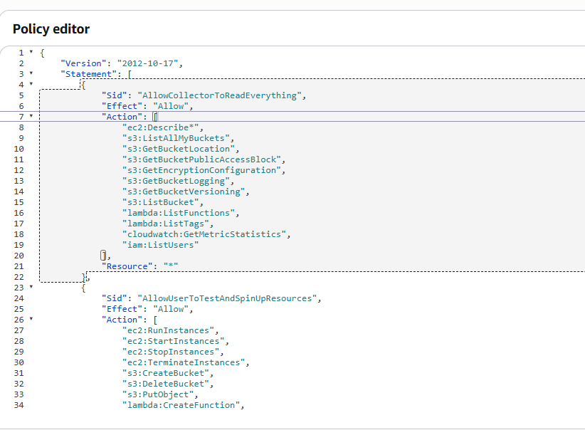
EC2 instances for testing purpose:
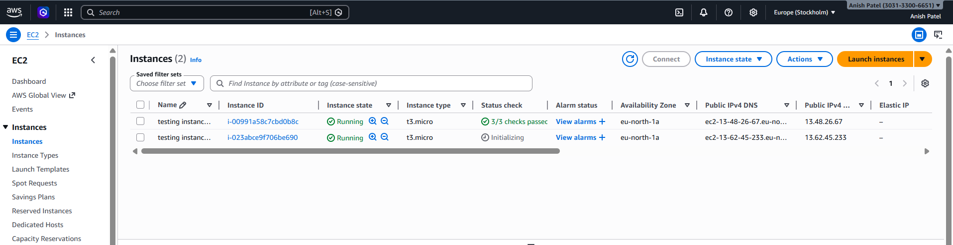
S3 buckets for testing purpose:
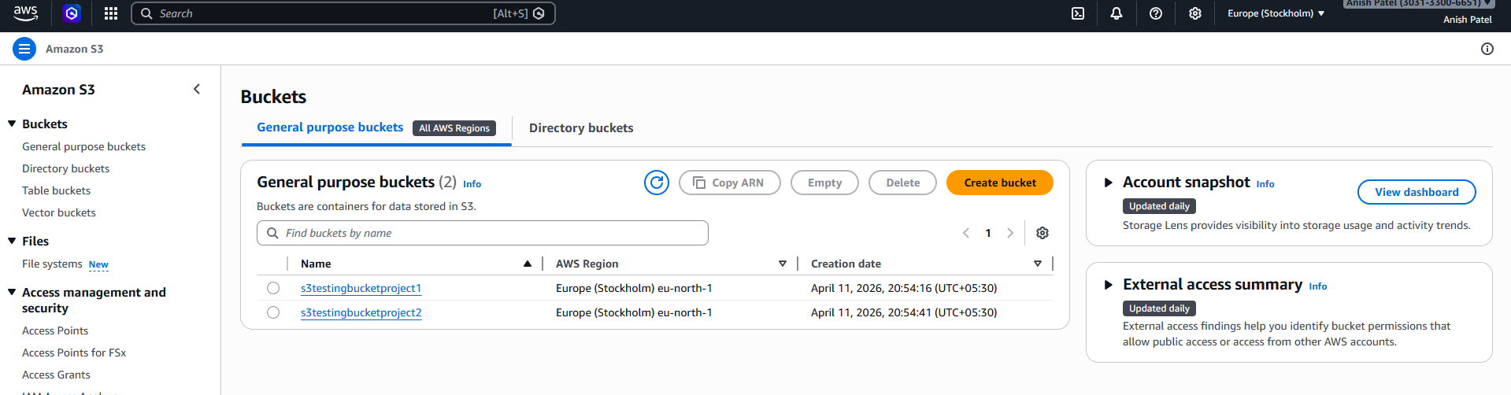
The new data is available on the dashboard:
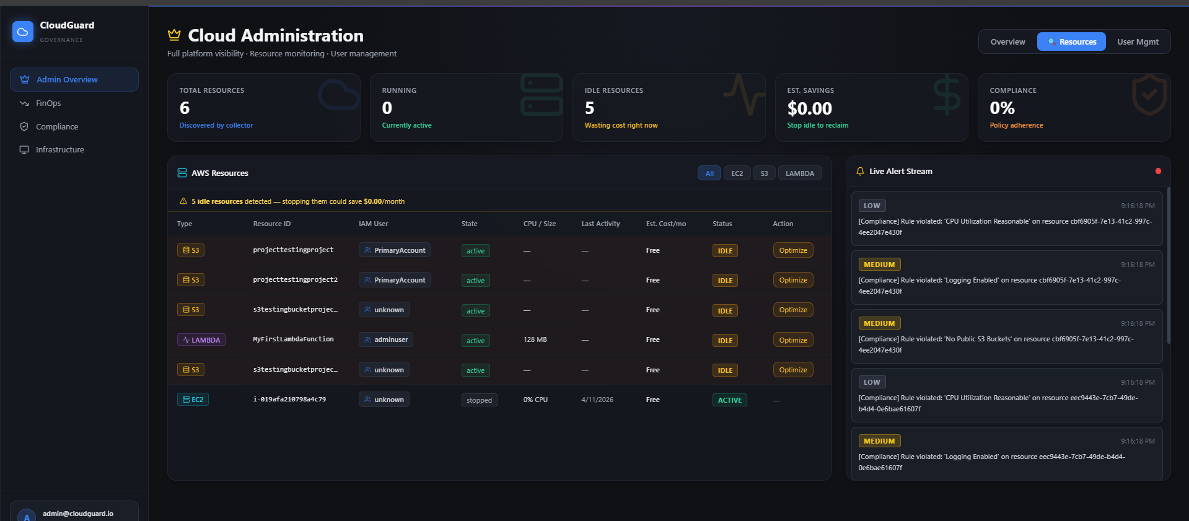
Compliance report:
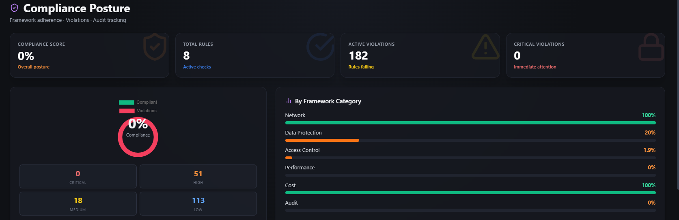Logs of compliance:
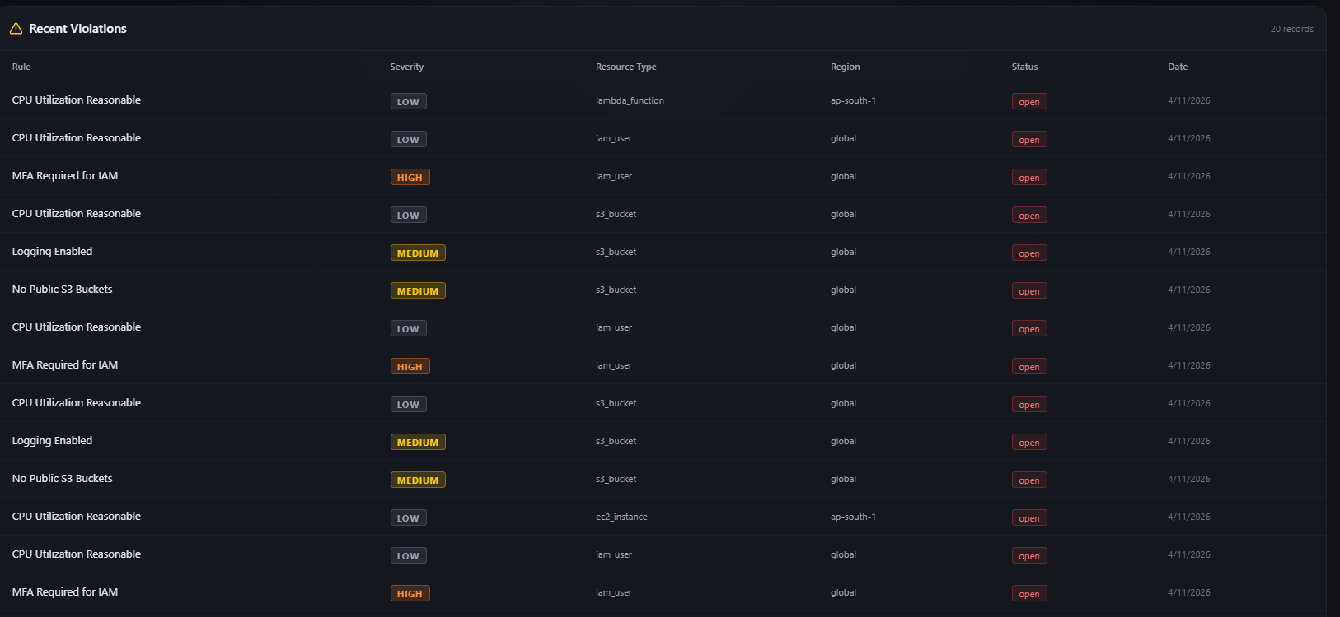
Overall data in IT administration dashboard:
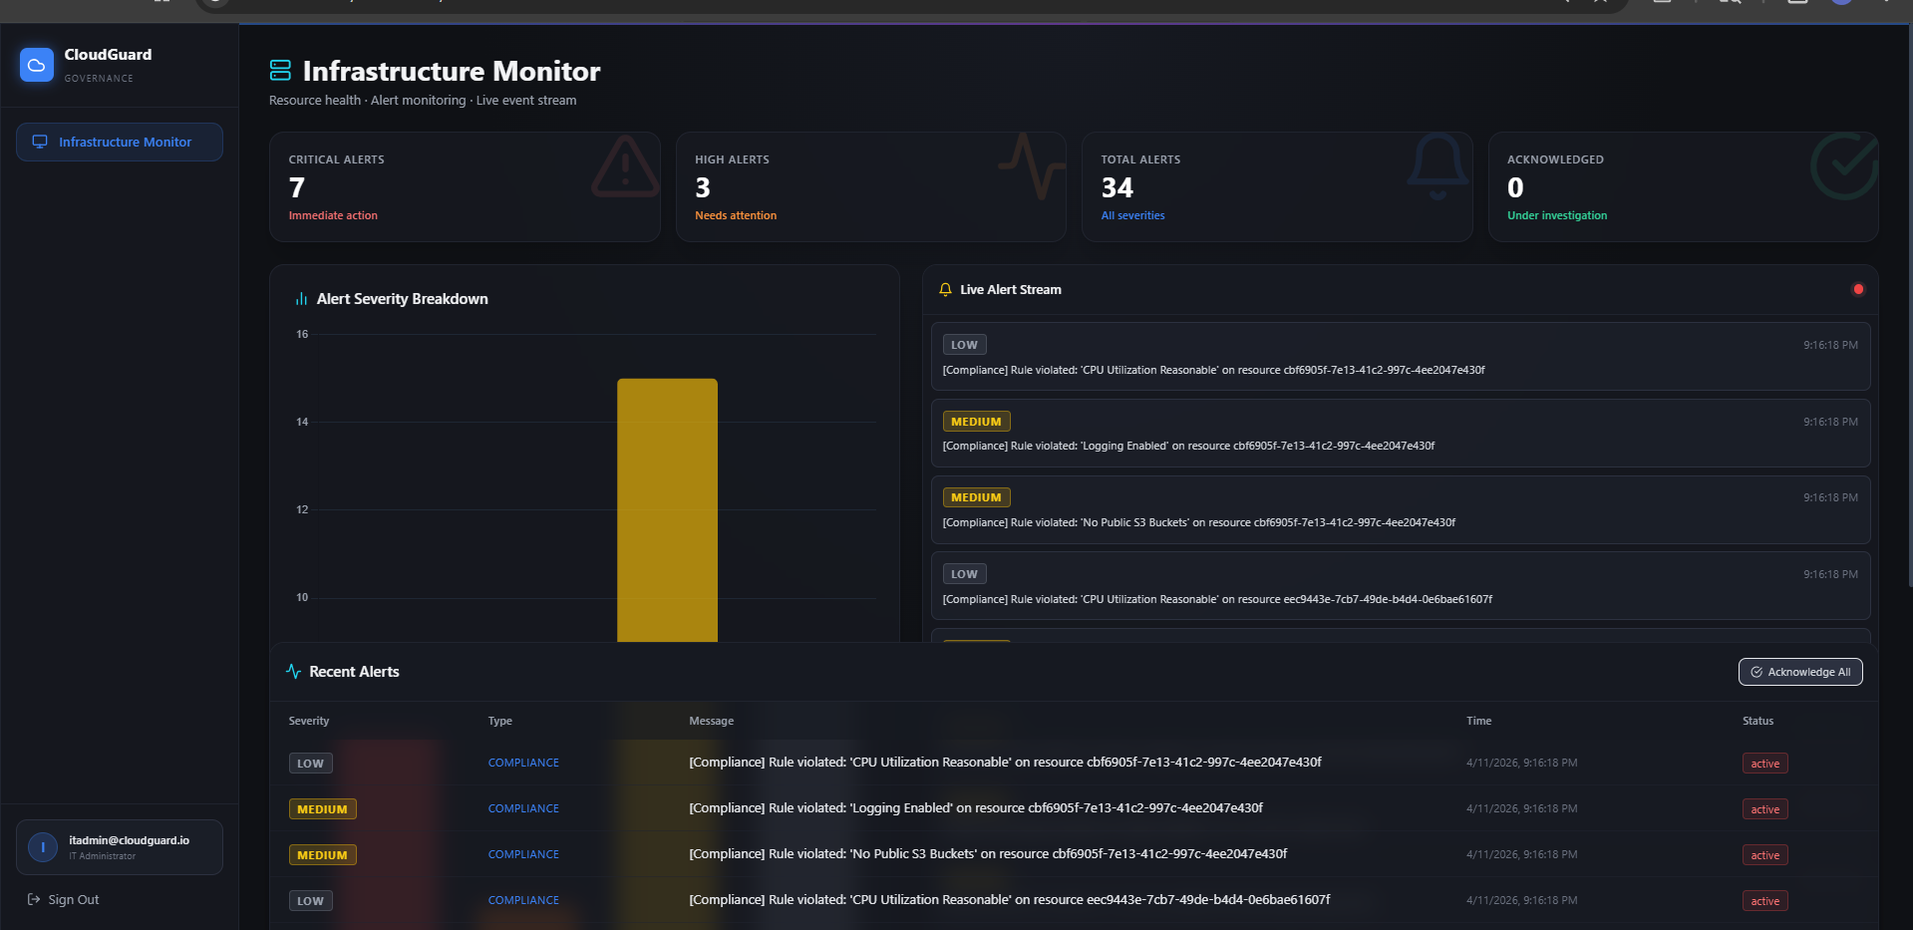
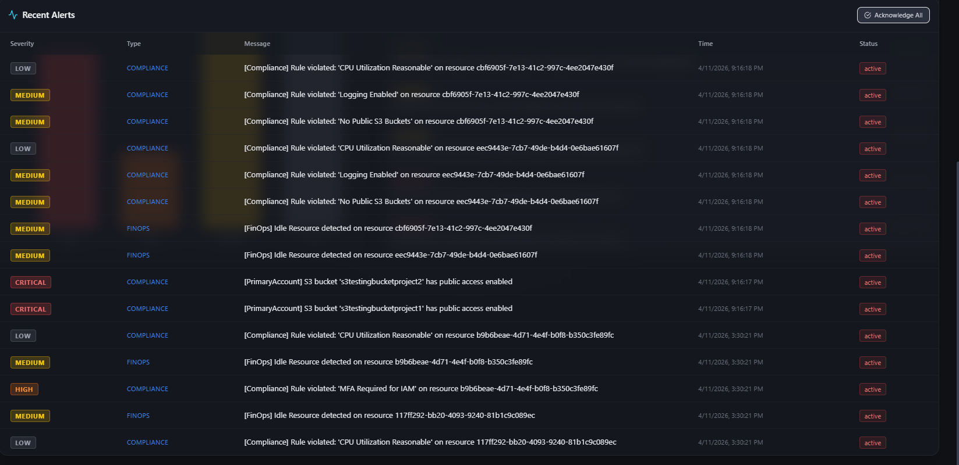

Finops showing unused resources that can save money:
